GLADSTONE

**SeafarersCentre**

Cnr Alf O'Rourke and Bryan Jordan Drive

Callemondah QLD 4680 PO Box 370, Gladstone DC QLD 4680 [admin@oladstonemts.org.au](mailto:admin@oladstonemts.org.au)

Ph: +61 7 4972 0355

ABN: 29 300 274 736

**New Volunteer at Gladstone Seafarers Centre**

**How did you come to hear about volunteering with us?**

**Are you prepared to volunteer for minimum of one month before we induct you at Terminals in Gladstone, if you are willing to be a bus driver? YES/NO**

**What is your skills set (brief employment history)? _**

Date of Application: ..................................... Date of Birth: ................................................................

Surname: ................................................... Given Names: ...............................................................

Address:...................................................................................................................................................

Email: ......................................................................................................................................................

Telephone: (H) ....................................... (W) ...........................................(M) ............................................

Emergency Contact:

Name: ........................................ Relationship: .................................... Telephone:.......................................

I would be interested volunteerinq in the following way/s:

|  |  |
| --- | --- |
| **AREA** | **PLEASE CIRCLE** |
| Shop sales/ Stock keeping/ Money exchange | YES/NO |
| Bus driver/ Shopping guide | YES/NO |
| Hospitality/ Chaplaincy/ Ship visitinq | YES/NO |
| Vehicle/ Grounds/ Centre Maintenance | YES/NO |

I would be available/prefer to work at the following time/s (please tick)

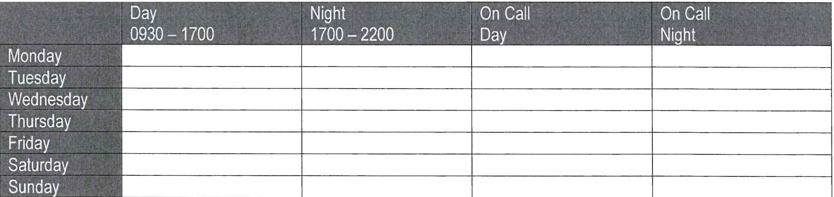

Have you ever been charged with a criminal offence or drink driving?



.....

--- ---....

----

..

---

Do you have any physical restrictions or health issues/ Allergies that may affect your ability to peFform-tbe role?

YES/NO

YES/NO

Details:

Any_ other comments: